Exercise 1: Total Sales

Design a program that asks the user to enter a store’s sales for each day of the week. The amounts should be stored in a list. Use a loop to calculate the total sales for the week and display the result.

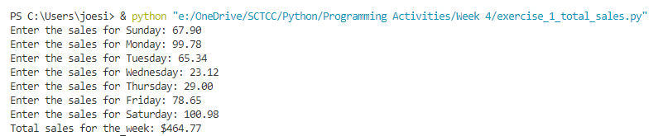

Exercise 2: Number Analysis Program

Design a program that asks the user to enter a series of 10 numbers. The program should store the numbers in a list then display the following data:

* The lowest number in the list
* The highest number in the list
* The total of the numbers in the list
* The average of the numbers in the list

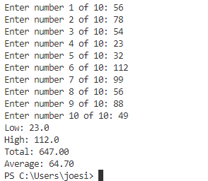

Exercise 3: Larger than a number

Write a program that accepts a number and a list of four numbers. Show the user input and display all the numbers in the list that are greater than the number n.

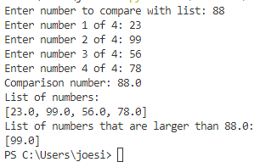

Exercise 4: Prime Number Generation

A positive integer greater than 1 is said to be prime if it has no divisors other than 1 and itself. A positive integer greater than 1 is composite if it is not prime. Write a program that asks the user to enter an integer greater than 1, then displays all the prime numbers that are less than or equal to the number entered. The program should work as follows:

* Once the user has entered a number, the program should populate a list with all the integers from 2 up through the value entered.
* The program should then use a loop to step through the list. The loop should pass each element to a function that displays the element whether it is a prime number.

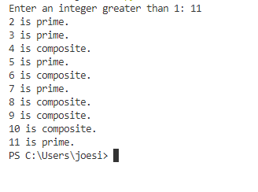

Exercise 5: Game Locker Puzzle (3)

A school has 100 lockers and 100 students.

* All lockers are closed on the first day of school. As the students enter, the first student, denoted S1, opens every locker.
* Then the second student, S2, begins with the second locker, denoted L2, and closes every other locker.
* Student S3 begins with the third locker and changes every third locker (closes it if it was open, and opens it if it was closed).
* Student S4 begins with locker L4 and changes every fourth locker. Student S5 starts with L5 and changes every fifth locker, and so on, until student S100 changes L100.

After all the students have passed through the building and changed the lockers, which lockers are open? Write a program to find your answer.

(Hint: Use a list of 100 Boolean elements, each of which indicates whether a locker is open (True) or closed (False). Initially, all lockers are closed.)

